FINANCIAL COMPLAINT ANALYSIS



Submitted By:

Raghav Aggarwal(102003274)

# 3COE11

Submitted to:

Ms Archana Singh

DASHBOARD:

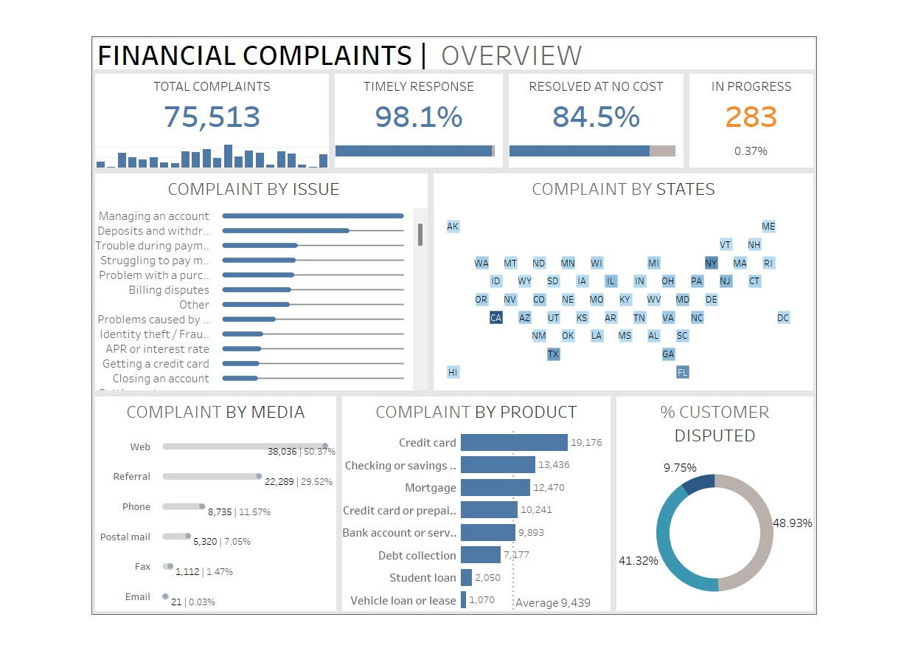

DATASET :

Table1:

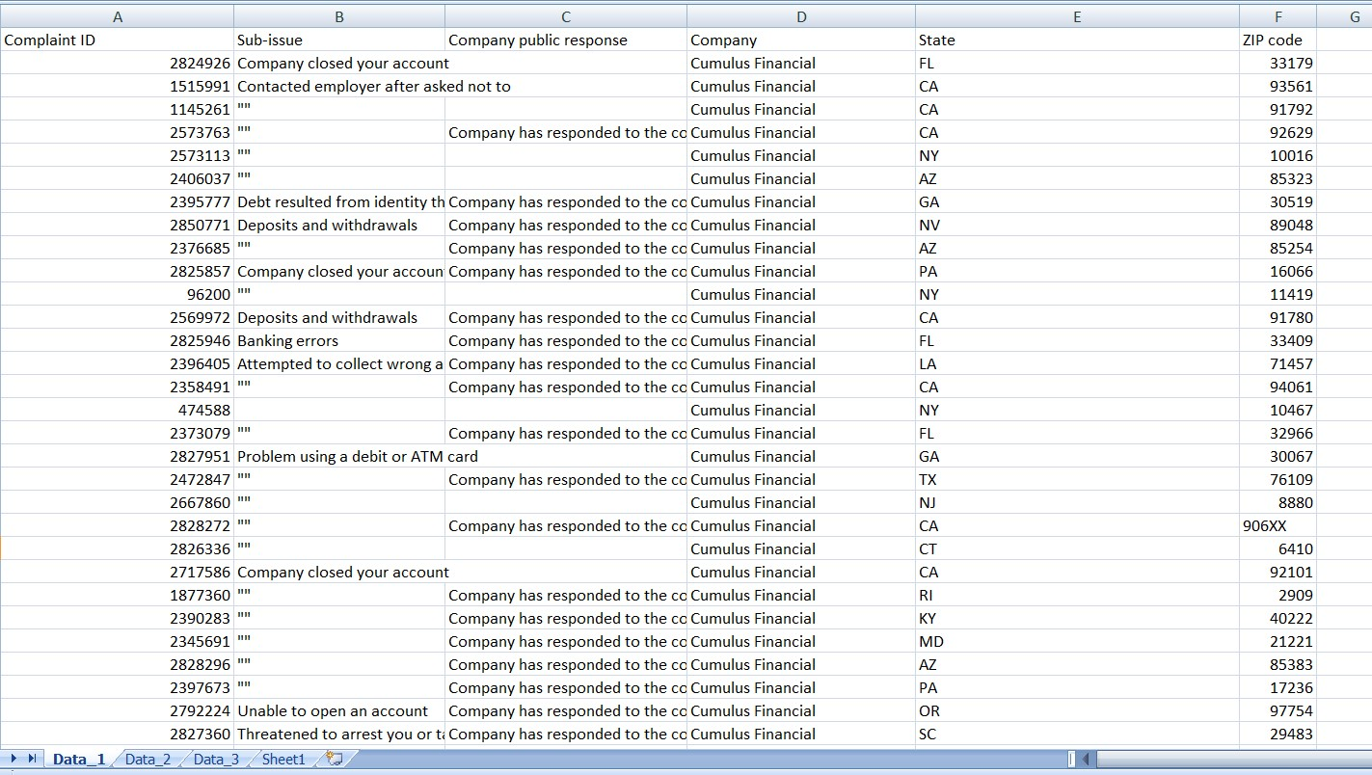

TABLE2:

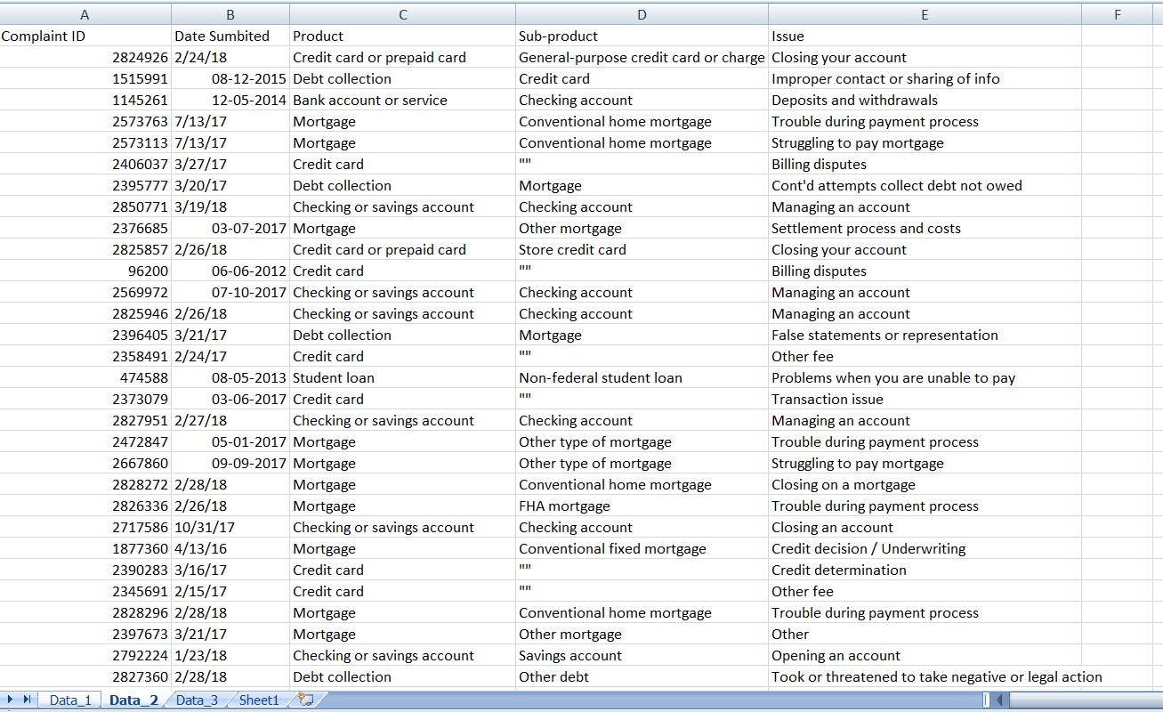

TABLE3:

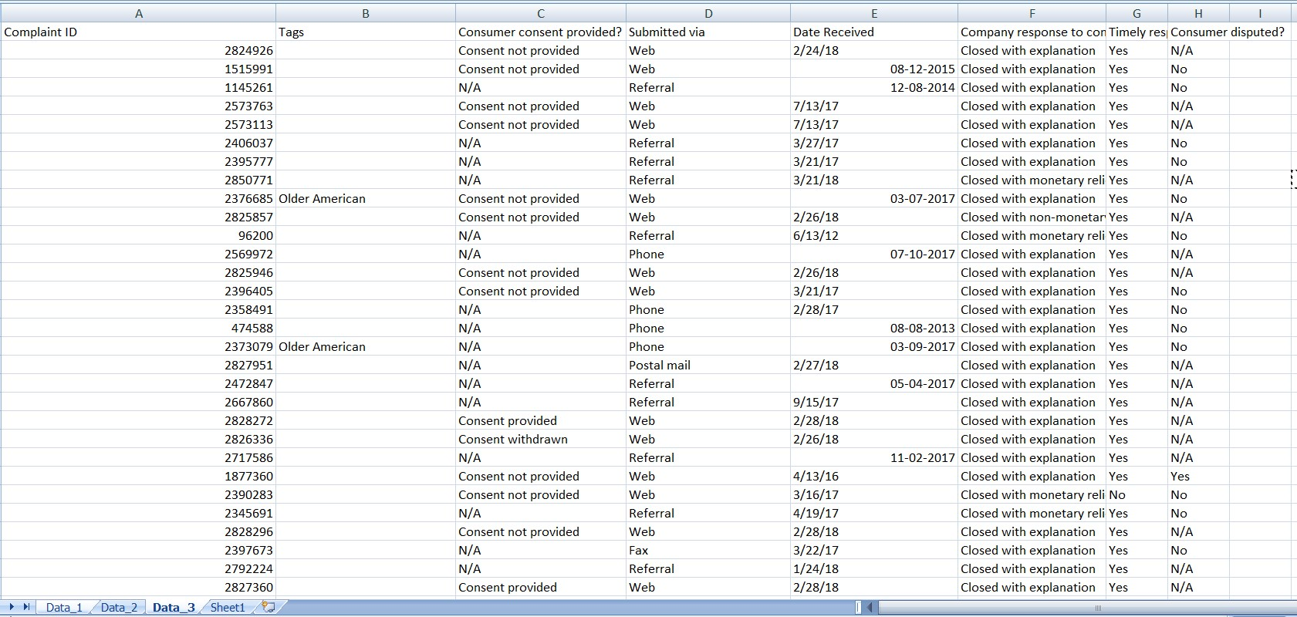

WHOLE DATASET:

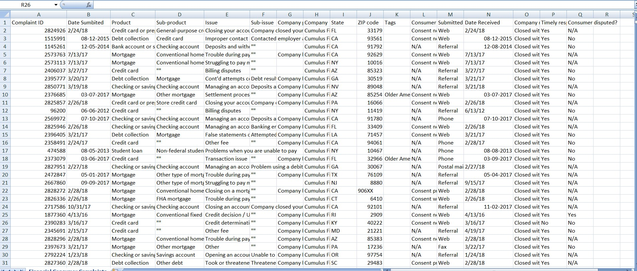

DATA REFINING STEPS:

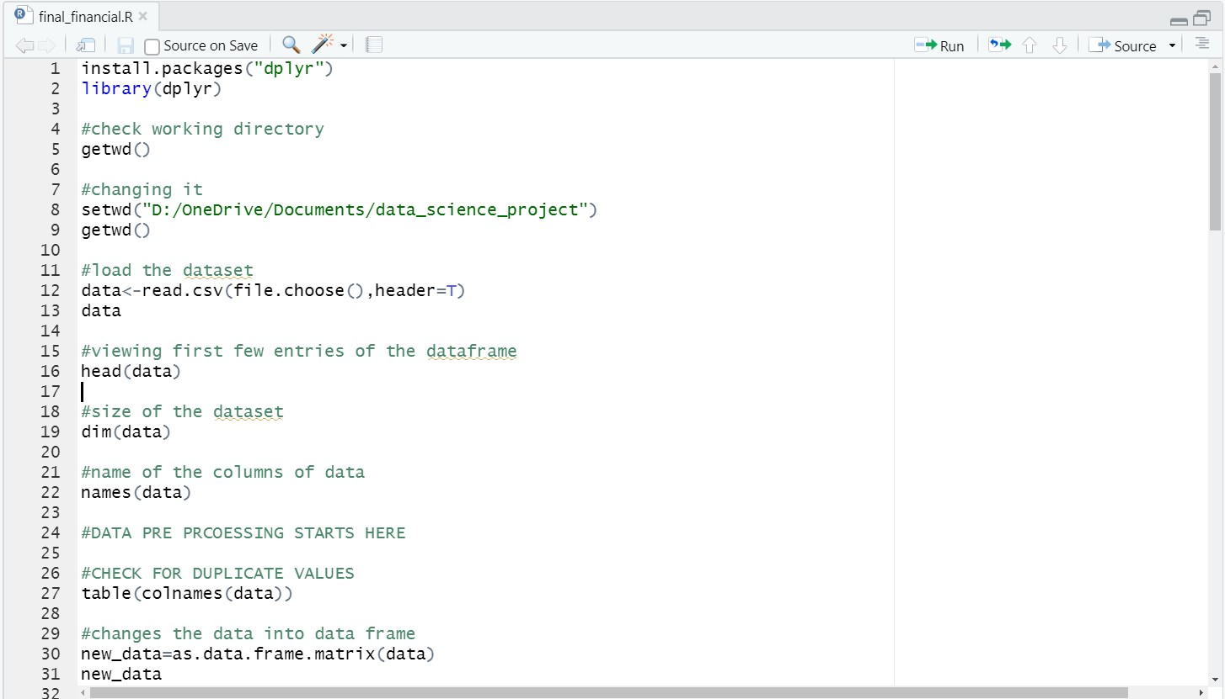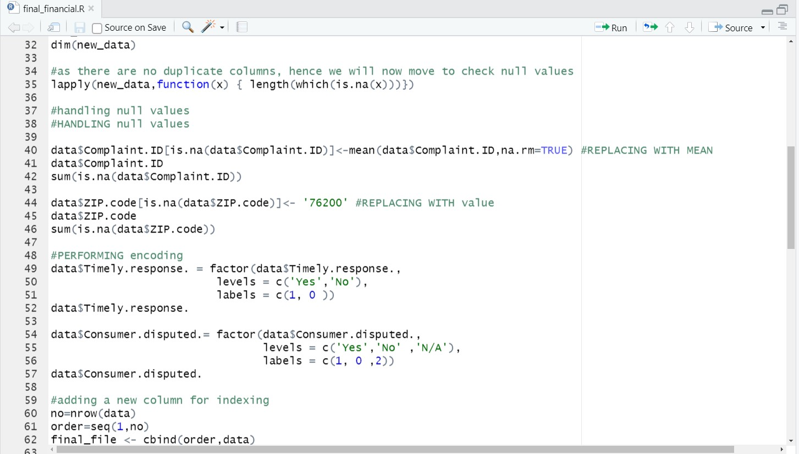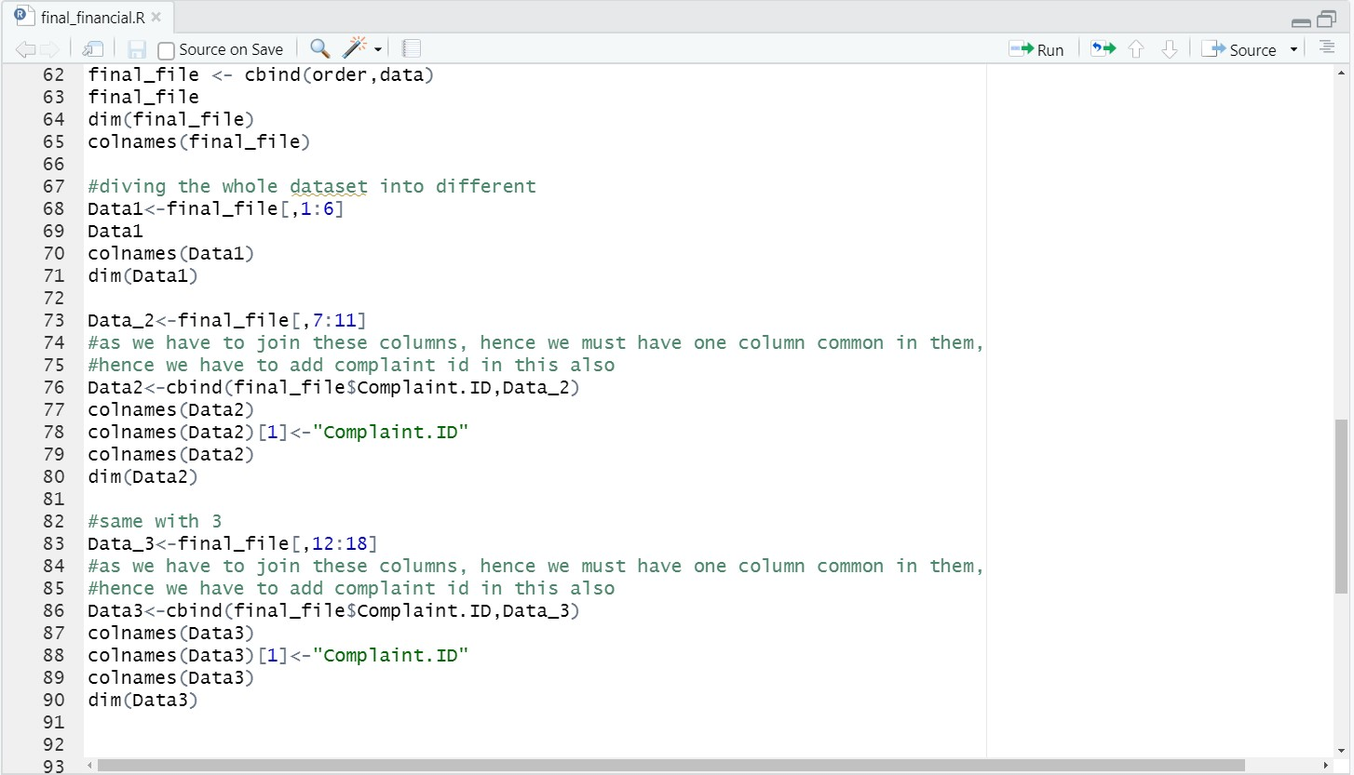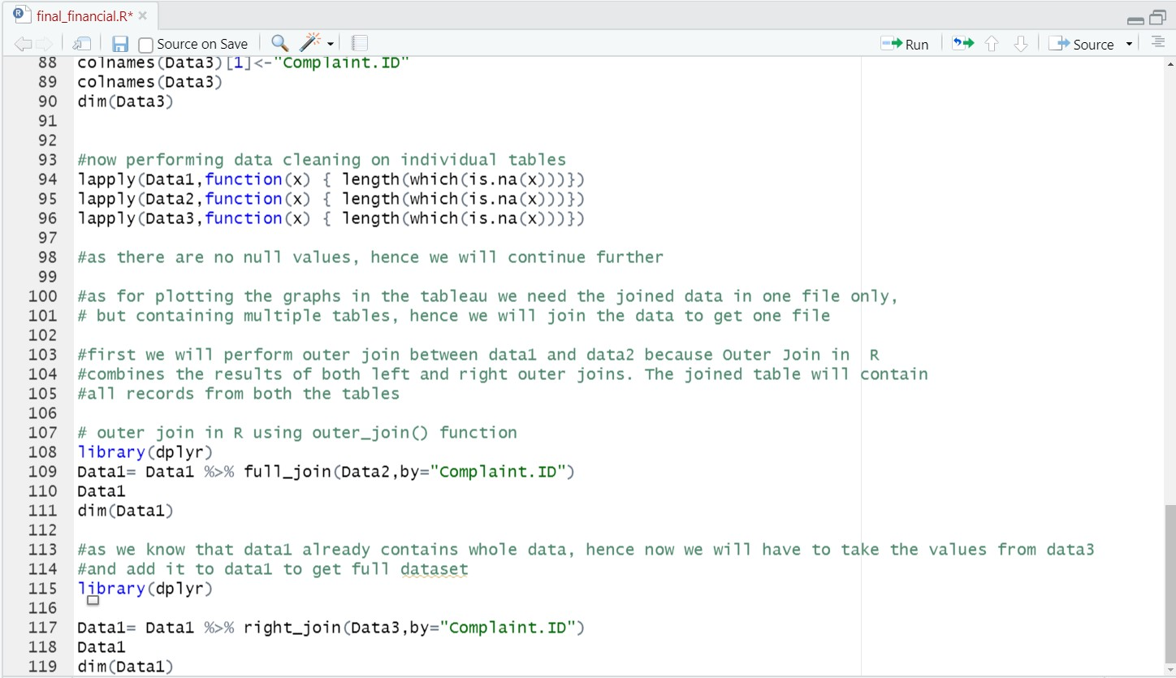

TABLEAU WORK:

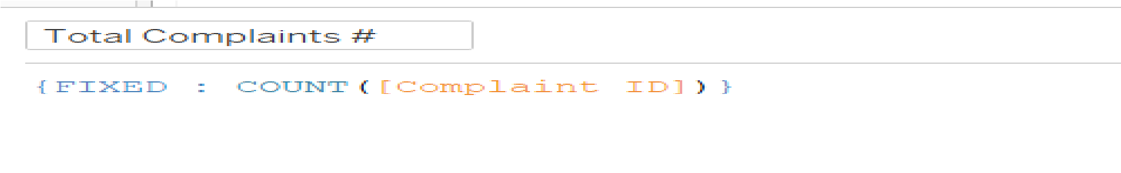UPLOADING DATASET AND JOIN IN DATA:

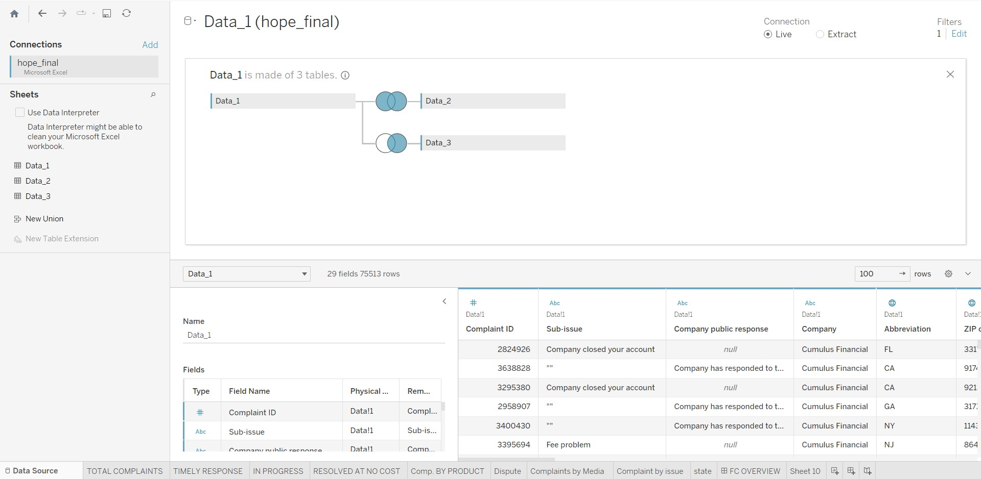

SHEET1 (TOTAL COMPLAINTS KPI):

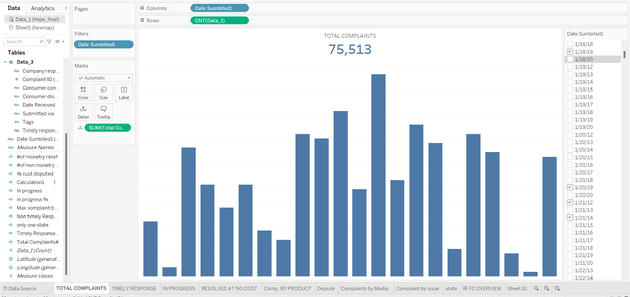

QUERY USED FOR THIS:

SHEET2 (TIMELY RESPONSE QUERY):

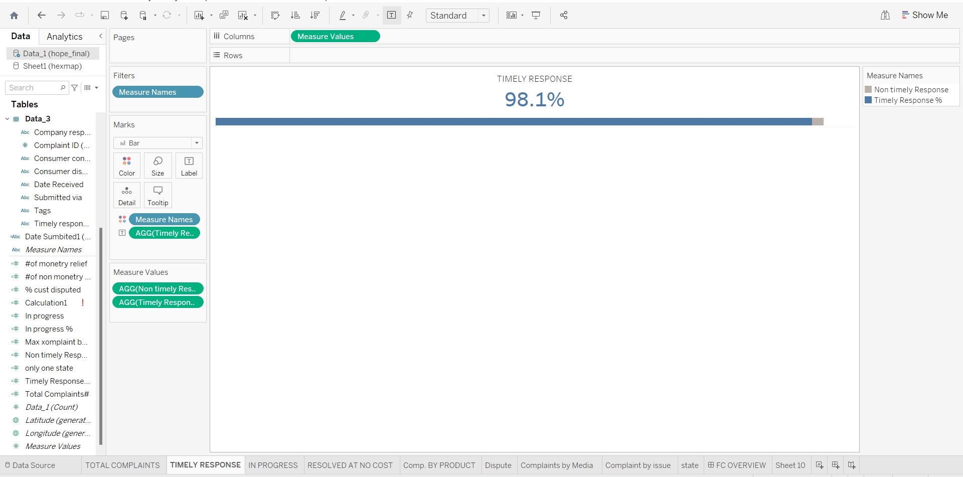

QUERY USED FOR THIS:

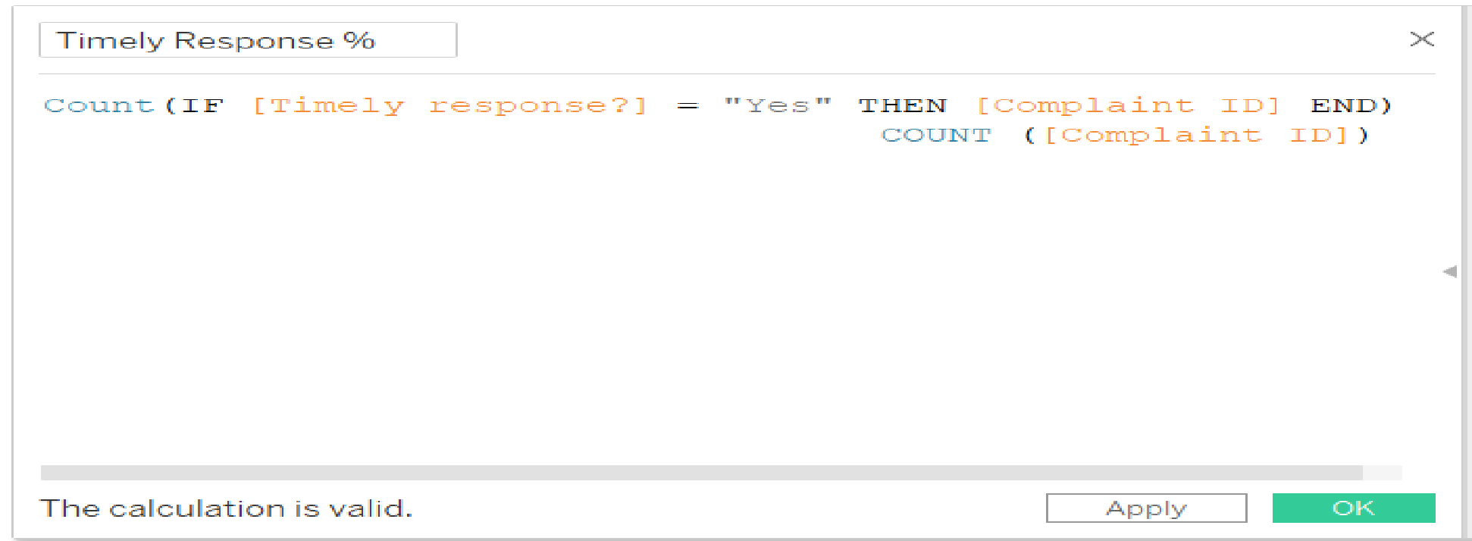

SHEET3 (IN PROGRESS):

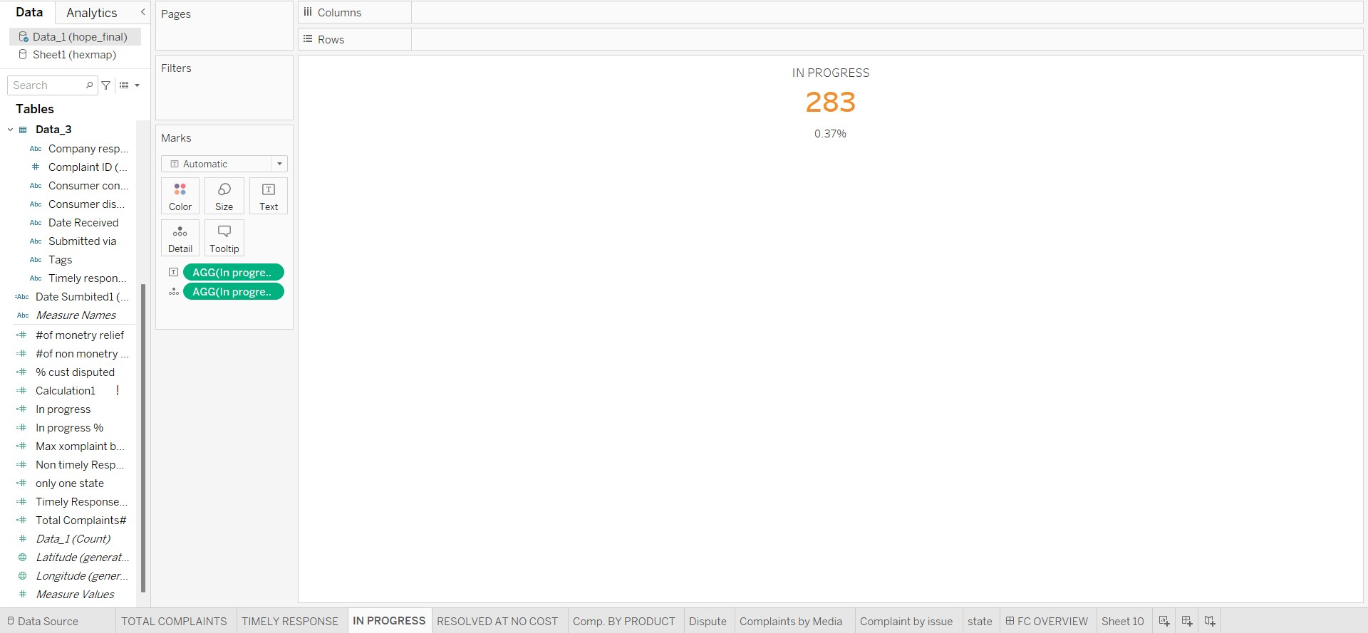

QUERY USED FOR THIS:

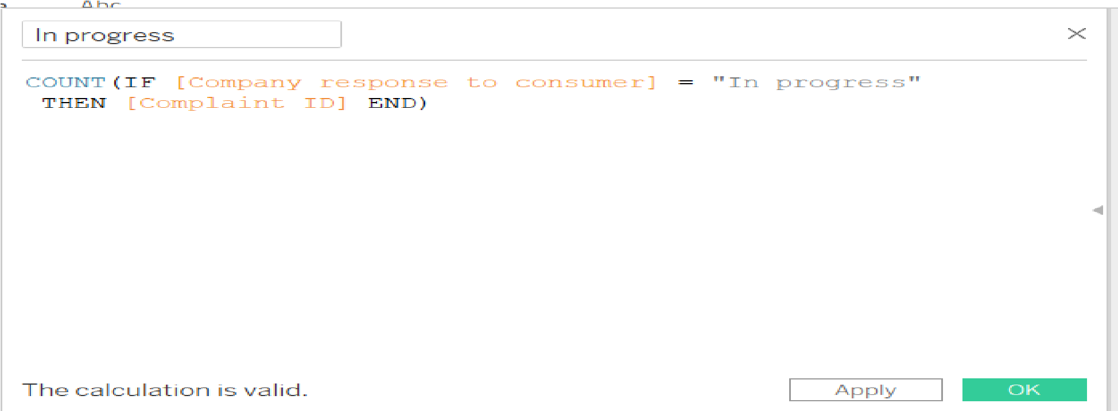

SHEET4 (RESOLVED AT NO COST):

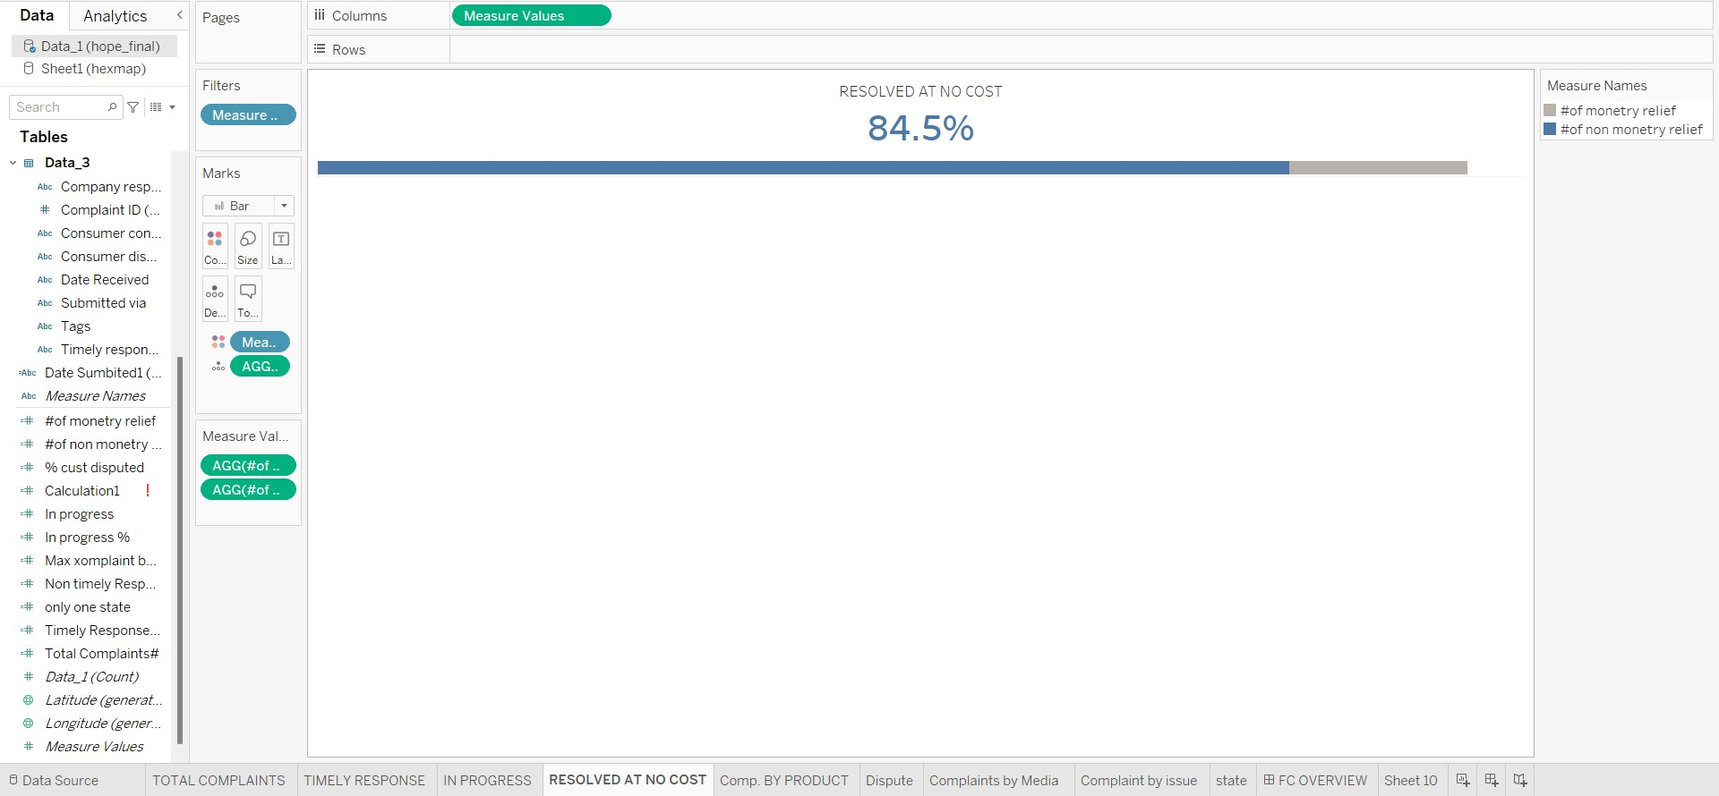

QUERY USED FOR THIS:

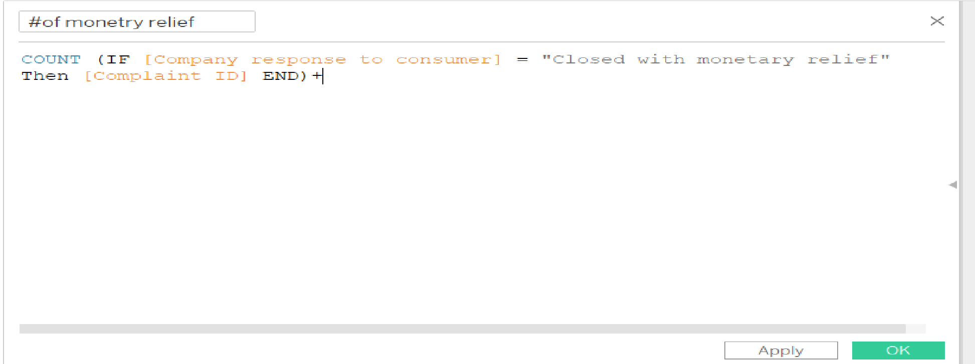

SHEET5 (COMPLAINT BY PRODUCT):

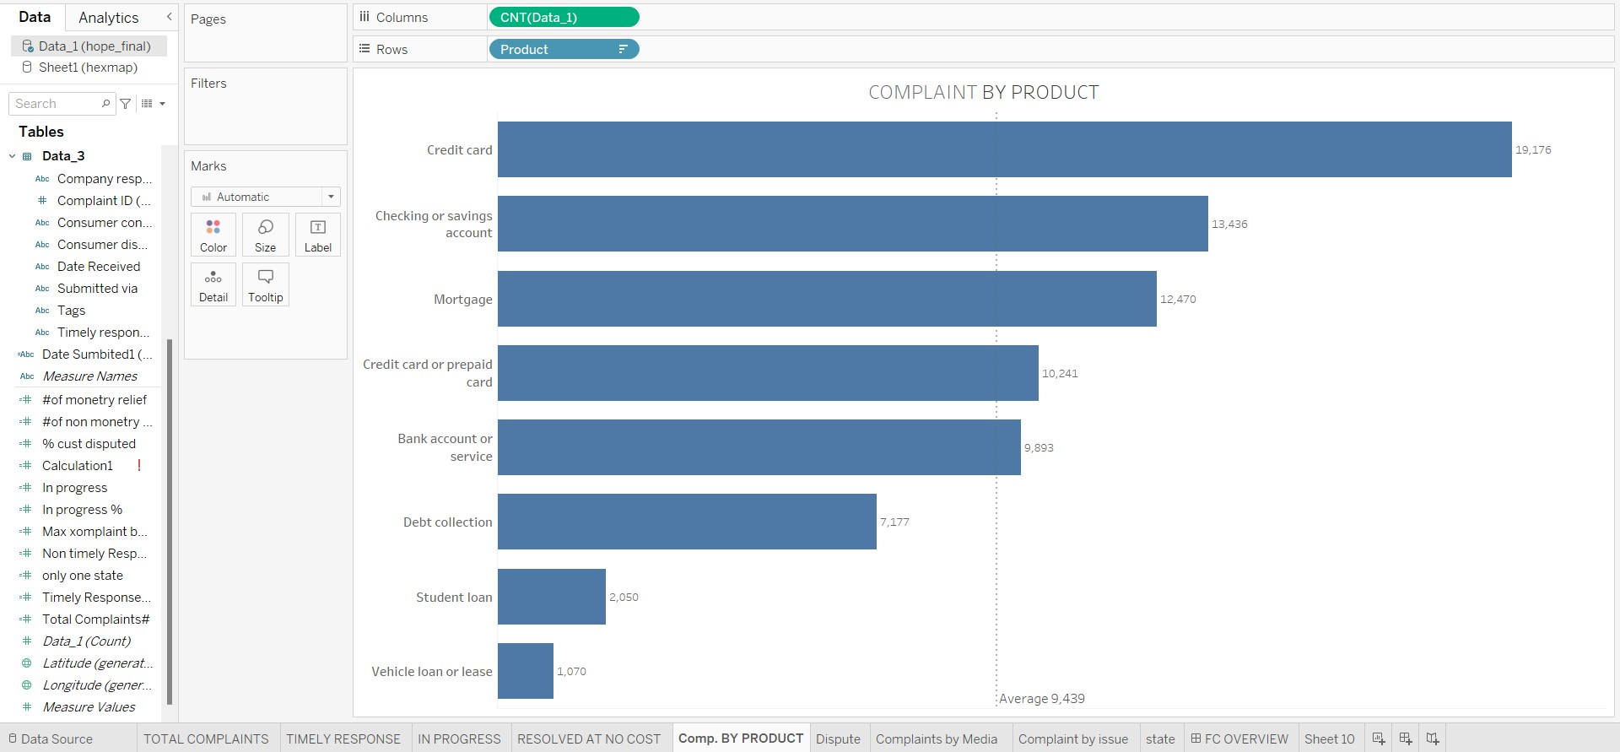

SHEET6 (CUSTOMER DISPUTE):

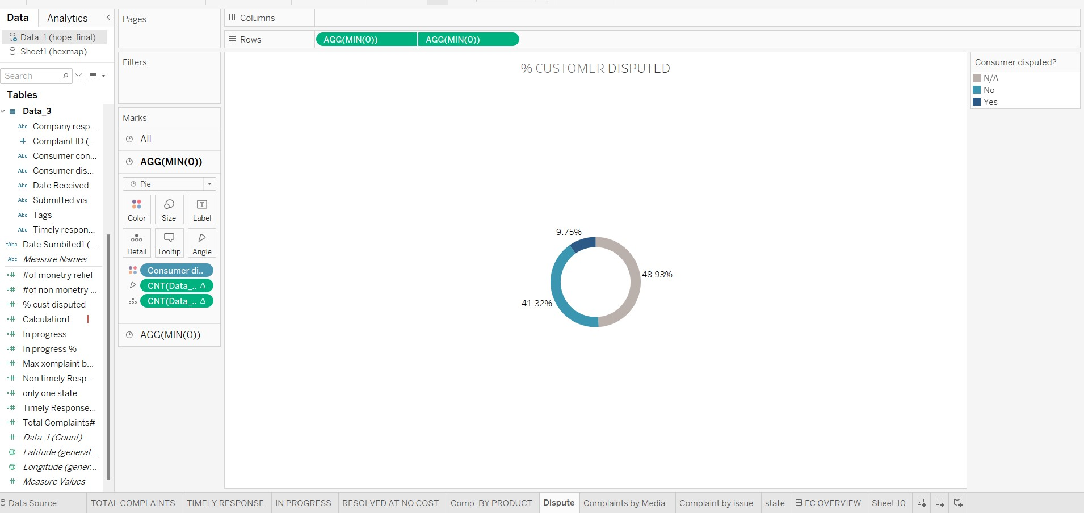

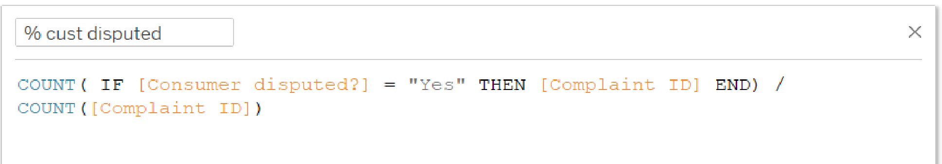QUERY USED FOR THIS:

SHEET7 (COMPLAINTS BY MEDIA):

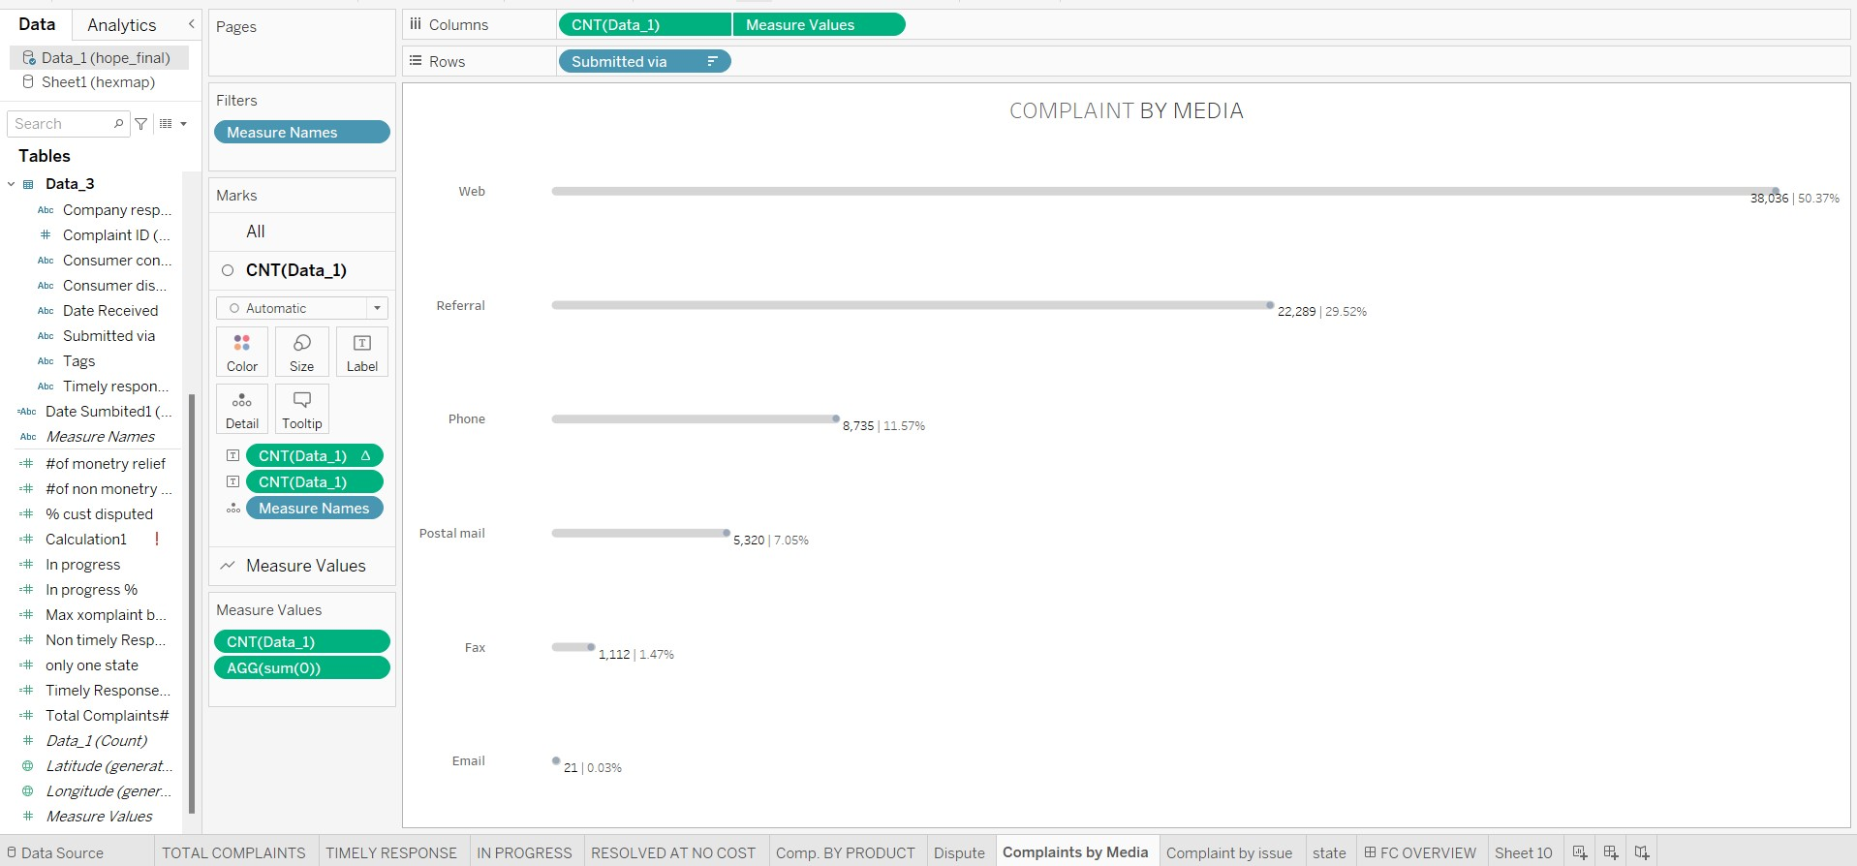

SHEET8 (COMPLAINTS BY ISSUE):

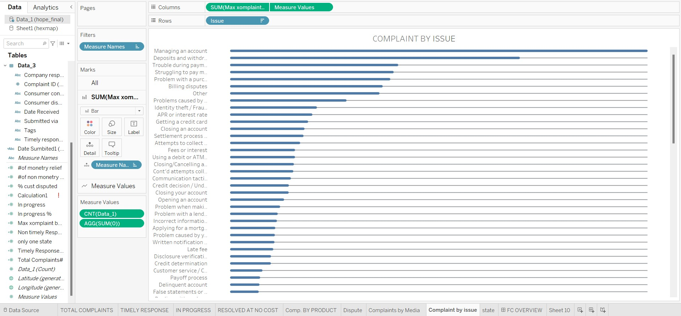

QUERY USED FOR THIS:

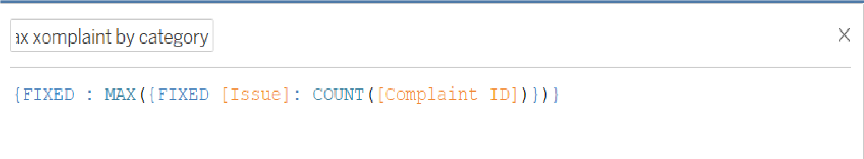

SHEET9 (COMPLAINTS BY STATE):

